**Assignment SQL**

**Setup:**

C:\WINDOWS\system32>cd C:\xampp\mysql\bin

C:\xampp\mysql\bin>mysql -u root -p

MariaDB [(none)]> create database hospital

-> ;

Query OK, 1 row affected (0.02 sec)

use hospital

**1.** **1. Create a database for the Hospital Management System based on your ER. Create appropriate tables & relationships.**

create table patient(patient_id int primary key, fname varchar(20), mname varchar(20), lname varchar(20), index p_name(fname,mname,lname), p_address varchar(30), p_age int);

create table doctor(doctor_id int primary key, doctor_name varchar(20), qualification varchar(20),contact_no int, dept_id int , foreign key(dept_id) references department(dept_id));

create table admit(admit_date date, discharge_date date, discharge boolean, patient_id int, foreign key(patient_id) references patient(patient_id));

insert into patient values(100,"mohan","","viswa","kunda",22);

insert into patient values(101,"sohan","","viswa","ald",23);

alter table patient add doc_id int;

update patient set doc_id=410 where patient_id=100

update patient set doc_id=411 where patient_id=101

insert into patient values(104,"ryan","","gosling","dc",24,402);

insert into patient values(105,"chris","","gosling","nyc",25,403);

insert into patient values(106,"maneesh","","bhatta","lko",25,404);

insert into department values(01,"neurology");

insert into department values(01,"neurology");

insert into department values(02,"icu");

insert into department values(03,"emergancy");

insert into department values(04,"maternity");

insert into department values(05,"oncology");

insert into doctor values(401,"dr. smith", "md",7777777777,2);

insert into doctor values(407,"dr. paul", "md",7777777777,2);

insert into doctor values(403,"dr. mandeep", "mbbs",7777777777,1);

insert into doctor values(402,"dr. suresh", "bds",8295144045,2);

insert into admit values(15-06-2020,18-07-2020,true,106);

update admit set admit_date=2020-06-15 where patient_id=106;

update admit set admit_date='2020-06-15' where patient_id=106;

update admit set discharge_date='2020-07-19' where patient_id=106;

insert into admit values('2020-06-22','2020-07-15',true,105);

insert into admit values('2020-06-22','2020-07-15',false,104);

insert into admit values('2020-06-22','2020-07-01',true,101);

insert into admit values('2020-06-02','2020-07-11',true,103);

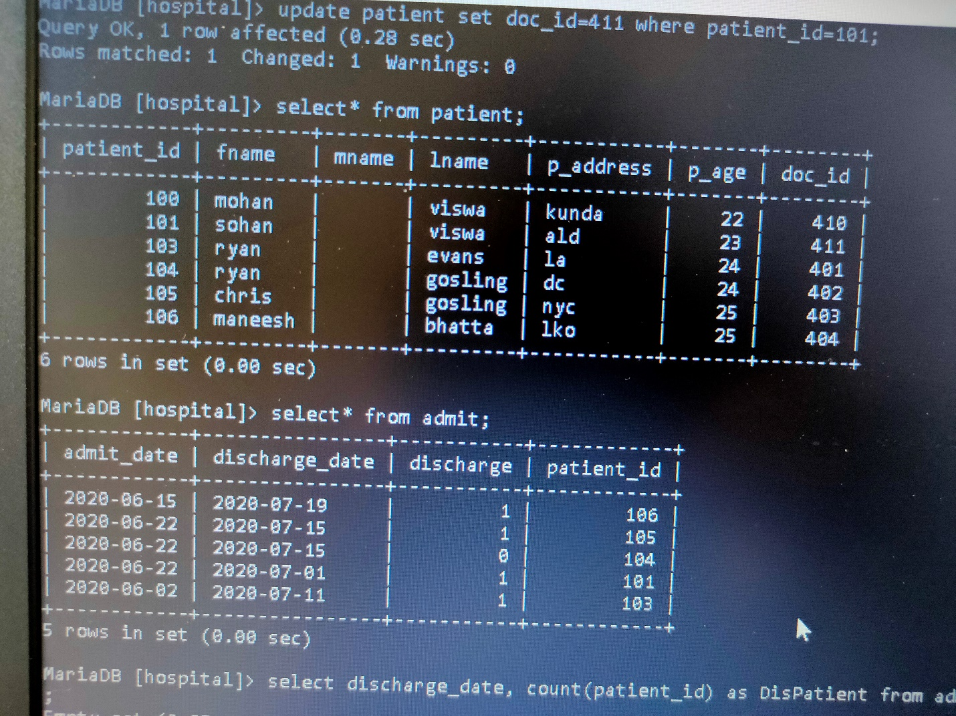

**2. Design a query to provide a list of doctors, which department they belong to and patients treated by them (if any)**

MariaDB [hospital]> select doctor.doctor_name, doctor.doctor_id,department.dept_name,department.dept_id, patient.patient_id,patient.fname

-> from doctor

-> join department on doctor.dept_id=department.dept_id

-> join patient on patient.doc_id=doctor.doctor_id;

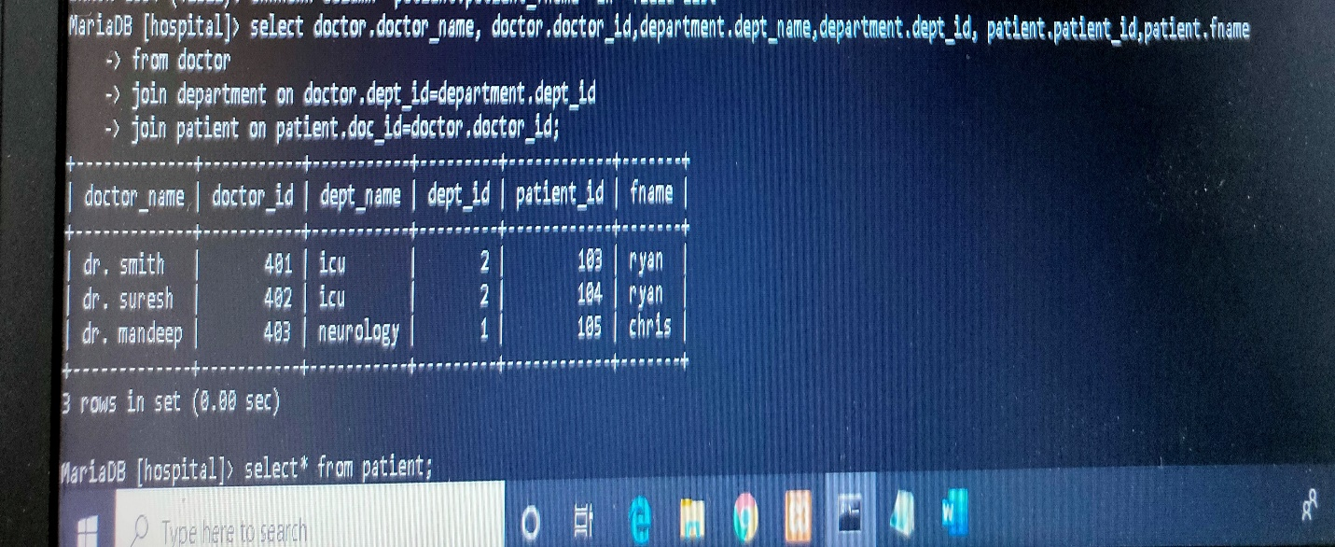

**3.** **Query to provide the count of patients discharged per day in the last week.**

MariaDB [hospital]> select discharge_date, count(patient_id) as DisPatient from admit where discharge_date between '2020-07-11' and '2020-07-19' group by discharge_date;

